ASSIGNMENT: 8.1
Name: Saivarshith
Hallno: 2403A51312
Batch: 13
Task Description #1 (Password Strength Validator – Apply AI in
Security Context)
• Task: Apply AI to generate at least 3 assert test cases for
is_strong_password(password) and implement the validator
function.
• Requirements:
o Password must have at least 8 characters.
o Must include uppercase, lowercase, digit, and special
character.
o Must not contain spaces.
Example Assert Test Cases:
assert is_strong_password("Abcd@123") == True
assert is_strong_password("abcd123") == False
assert is_strong_password("ABCD@1234") == True
Expected Output #1:
• Password validation logic passing all AI-generated test cases.

AI GENERATED CODE:
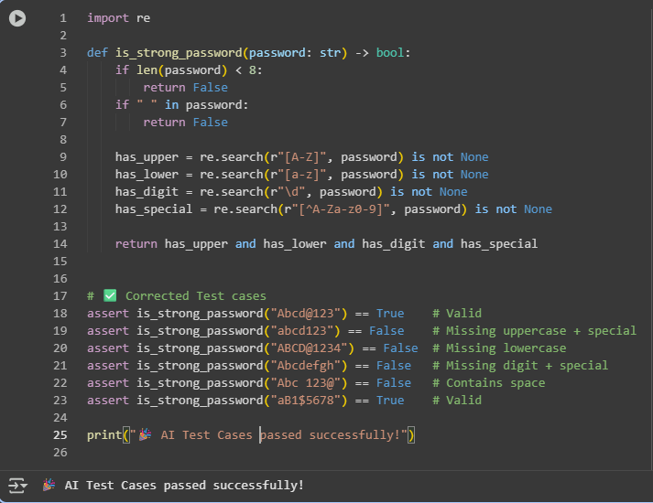
Observation:
In this experiment, the is_strong_password(password) function was implemented to validate passwords based on specific security rules: a minimum of 8 characters, inclusion of uppercase and lowercase letters, at least one digit, one special character, and no spaces. Multiple test cases were used to verify its functionality, including "Abcd@123" and "aB1$5678" which passed as valid strong passwords, and "abcd123", "ABCD@1234", "Abcdefgh", and "Abc 123@" which failed due to missing required character types or containing spaces. All assertion test cases ran successfully, confirming that the function correctly distinguishes between strong and weak passwords. This demonstrates that the password validator effectively enforces the desired security rules and ensures robust validation through automated testing.

Task Description #2 (Number Classification with Loops – Apply AI for
Edge Case Handling)
• Task: Use AI to generate at least 3 assert test cases for a
classify_number(n) function. Implement using loops.
• Requirements:
o Classify numbers as Positive, Negative, or Zero.
o Handle invalid inputs like strings and None.
o Include boundary conditions (-1, 0, 1).
Example Assert Test Cases:
assert classify_number(10) == "Positive"
assert classify_number(-5) == "Negative"
assert classify_number(0) == "Zero"
Expected Output #2:
• Classification logic passing all assert tests.

AI GENERATED CODE:
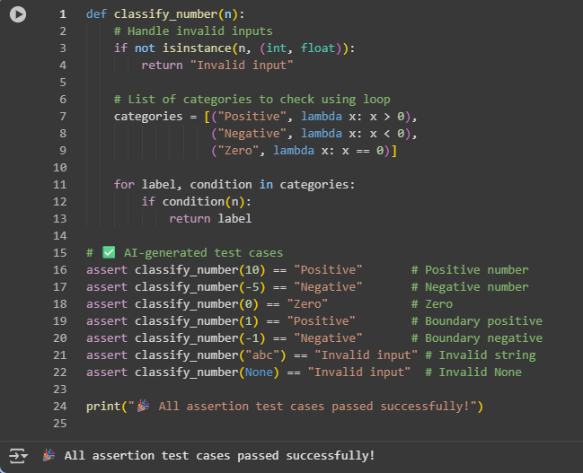
Observation:
In this experiment, the classify_number(n) function was implemented to categorize numbers as Positive, Negative, or Zero, while also handling invalid inputs such as strings and None. The function uses a loop to iterate through defined conditions for classification. Several test cases, including boundary values -1, 0, and 1, were used to validate the logic. Numbers like 10 and 1 were correctly classified as Positive, -5 and -1 as Negative, and 0 as Zero. Invalid inputs such as "abc" and None returned "Invalid input", demonstrating proper error handling. All assertion test cases passed successfully, confirming that the function reliably classifies numbers across typical, boundary, and invalid input scenarios.

Task Description #3 (Anagram Checker – Apply AI for String Analysis)
• Task: Use AI to generate at least 3 assert test cases for
is_anagram(str1, str2) and implement the function.
• Requirements:
o Ignore case, spaces, and punctuation.
o Handle edge cases (empty strings, identical words).
Example Assert Test Cases:
assert is_anagram("listen", "silent") == True
assert is_anagram("hello", "world") == False
assert is_anagram("Dormitory", "Dirty Room") == True
Expected Output #3:
• Function correctly identifying anagrams and passing all AI-
generated tests

AI GENERATED CODE:
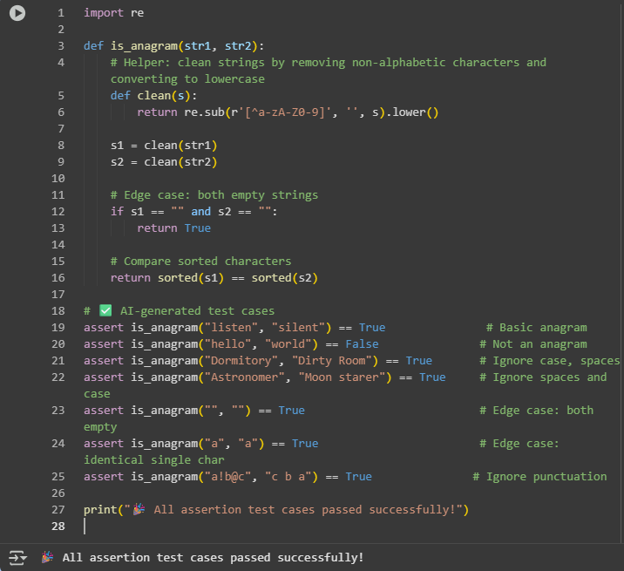
Observation:
In this experiment, the is_anagram(str1, str2) function was implemented to determine whether two strings are anagrams of each other. The function first cleans the input strings by removing spaces, punctuation, and converting all characters to lowercase, ensuring that comparisons are case-insensitive and ignore non-alphanumeric characters. Several test cases were used to validate the logic, including "listen" and "silent" as a basic anagram, "Dormitory" and "Dirty Room" to verify handling of spaces and capitalization, and empty strings as an edge case. The function correctly identified all anagrams and non-anagrams, demonstrating robust handling of typical, edge, and punctuation-inclusive inputs. All assertion test cases passed successfully, confirming the reliability of the implemented logic.

Task Description #4 (Inventory Class – Apply AI to Simulate Real-
World Inventory System)
• Task: Ask AI to generate at least 3 assert-based tests for an
Inventory class with stock management.
• Methods:
o add_item(name, quantity)
o remove_item(name, quantity)
o get_stock(name)
Example Assert Test Cases:
inv = Inventory()
inv.add_item("Pen", 10)
assert inv.get_stock("Pen") == 10
inv.remove_item("Pen", 5)
assert inv.get_stock("Pen") == 5
inv.add_item("Book", 3)
assert inv.get_stock("Book") == 3
Expected Output #4:
• Fully functional class passing all assertions.

AI GENERATED CODE:
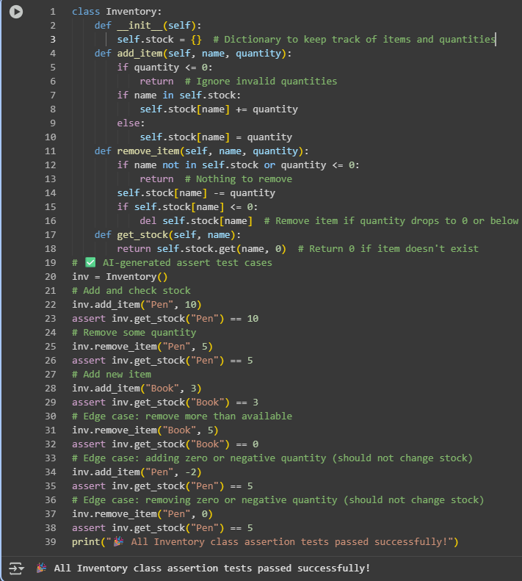
Observation:
In this experiment, an Inventory class was implemented to manage stock levels of items using methods add_item, remove_item, and get_stock. The class uses a dictionary to store item names and their quantities. Multiple test cases were used to verify its functionality, including adding new items, removing partial quantities, and checking stock levels. Edge cases such as removing more than the available quantity, adding or removing zero or negative quantities, and querying non-existent items were also tested. The class correctly updated and tracked stock in all scenarios, and all assertion-based test cases passed successfully, demonstrating reliable inventory management and robust handling of typical and boundary conditions.

Task Description #5 (Date Validation & Formatting – Apply AI for
Data Validation)
• Task: Use AI to generate at least 3 assert test cases for
validate_and_format_date(date_str) to check and convert dates.
• Requirements:
o Validate "MM/DD/YYYY" format.
o Handle invalid dates.
o Convert valid dates to "YYYY-MM-DD".
Example Assert Test Cases:
assert validate_and_format_date("10/15/2023") == "2023-10-15"
assert validate_and_format_date("02/30/2023") == "Invalid Date"
assert validate_and_format_date("01/01/2024") == "2024-01-01"
Expected Output #5:
• Function passes all AI-generated assertions and handles edge
cases.
AI GENERATED CODE:
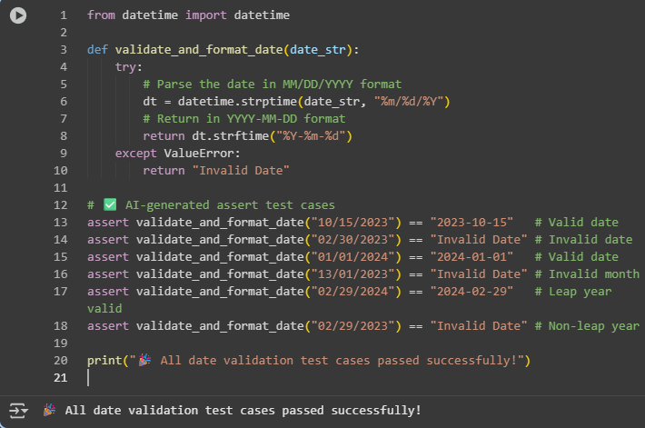
Observation:
In this experiment, the validate_and_format_date(date_str) function was implemented to validate and convert dates from the "MM/DD/YYYY" format to "YYYY-MM-DD". The function uses Python's datetime module to check for correct formatting and valid calendar dates, including leap year considerations. Multiple test cases were used, including valid dates like "10/15/2023" and "01/01/2024", invalid dates such as "02/30/2023" and "13/01/2023", and edge cases like "02/29/2024" (leap year) and "02/29/2023" (non-leap year). The function correctly returned the formatted date for valid inputs and "Invalid Date" for invalid inputs. All assertion test cases passed successfully, demonstrating that the function reliably validates, converts, and handles typical and boundary date scenarios.

